New Headway Upper-Intermediate 4th Edition
Date:​​……/March/2023
Unit 8 How remarkable!
Teacher’s name | Ly Sreydy | Grade/Year Level | E9, E10
Lesson  Page | Reading: Olympic champion  NA | Duration (minutes) | 45 minutes
Lesson Objectives | By the end of the lesson, students will be able to:  - Knowledge: properly discuss about “Olympic champion” through whole group discussion. (Understand)  - Skills: properly read and answer the reading text through exercise. (Apply)  - Attitude: properly practice reading skill strategy. (Apply)
Resources Needed | LCD projector, Slides, Computer, SNB, WB, Marker. etc.

Stages | Activities (Content) | Interactions | Timing
- Opening | - Greeting  - T & SS greet each other.  - Warm-up activities  - T. asks SS about general questions to draw their attention.  (How are you today? How do you feel today? Did you sleep well last night?)  - Checking of students’ attendance  - T. checks students' attendance via NGS Mobile App.  - Reviewing previous lesson  - T. asks SS to tell the class about what they learnt from the previous lesson.  - Then, T. called one or two students to share their answers to the whole class. | T SS | 5mns
- Pre-reading | - Set the scene  - T. uses conceptual questions to link to the lesson today.  - T. asks some questions.  - Do you like sport?  - Why some people take sport as their profession?  - What can you do to become Olympic champion?  SS answer ……  - T. asks Ss. to guess what they are going to study today.  - So, today we are going to study about “reading: Olympic champion”  - Pre-teach vocabulary  Champion (n):  Psychological (adj):  Genetic (n):  Enhance (v):  Attribute (v):  Generate (v):  - SS check the meaning of the words using dictionary.  - T. elicits the meaning from SS.  - Then, SS note down the meaning into note book. | T SS | 8mns
- While-reading | - choose the correct answer  - T. asks SS to see the work T. sent  - SS work in pair read the text and do exercises.  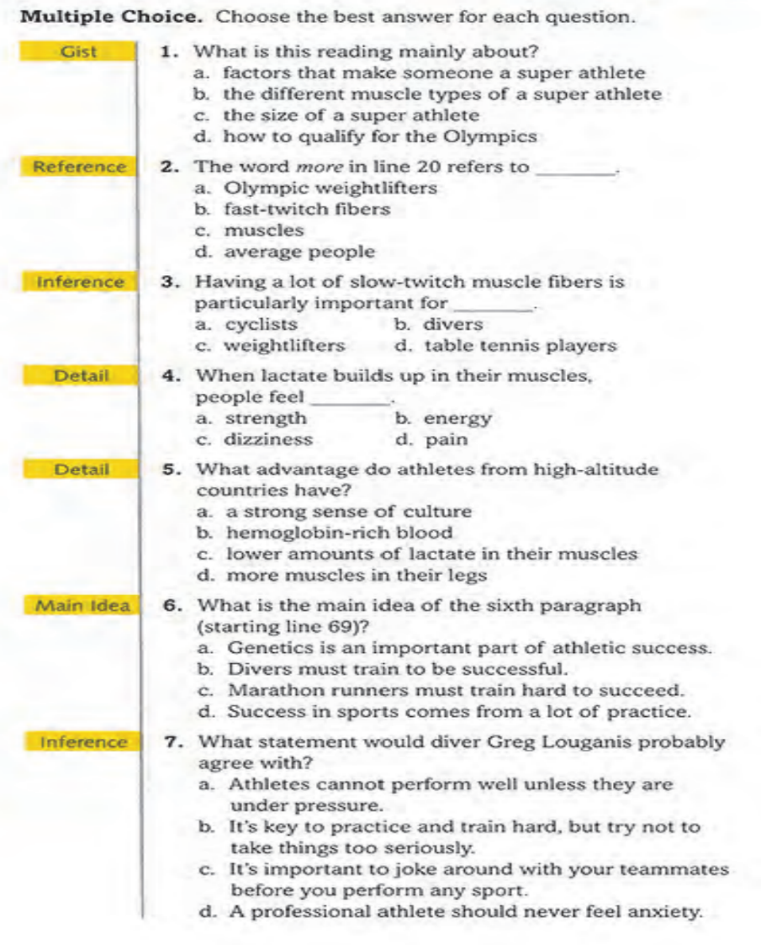  - T. walks around and facilitates | T SS  SS SS | 20mns
- Post-reading | - Critical thinking  - T. asks SS to talk to discuss in pair to 2 discussion questions.  - What do you think Louganis mean when he says most divers are too much in their head? How might this effect an athlete’s performance?  - One of the aims of the Olympic Games is to improve relationships among countries. Do you think they achieve this?  - SS share their idea as whole class.  - T. facilitates and give feedback | T SS  SS. SS | 7mns
- Closure | - T. wraps up the lesson and gives SS. a message.  - T. and SS say goodbye. | T SS | 5mns
Remarks: T = Teacher; SS = Students; mns =Minutes
ថ្ងៃសុក្រ ១១រោច​ ខែផល្គុន ឆ្នាំខាល ចត្វាស័ក ព.ស.២៥៦៦
រាជធានីភ្នំពេញ ថ្ងៃទី ១៧ ខែ មិនា ឆ្នាំ២០២៣
គ្រូបង្រៀនភាសាអង់គ្លេស
ហត្ថលេខា

លី ស្រីឌី
បានឃើញ និងឯកភាព
ជ.នាយករងទទួលបន្ទុកសាលារៀនជំនាន់ថ្មី
គ្រូប្រឹក្សាគរុកោសល្យ

​​​​​​​​​​​​​​​​​​​​​​​​​​​
គឹម គុយលី

បានឃើញ និងពិនិត្យ
ប្រធានក្រុមបច្ចេកទេសភាសាអង់គ្លេស
ហត្ថលេខា

ស៊ាម រុន

