## Sprint 1 - Commencing 29th May 2023 – Scope of Work

*Observic Visualisation slides 1-5, 7, 13, and 30-37 are most relevant to this Sprint.*

### Creating a new Account/Instance

* 1. The current Essential platform allows the manual setup of an account for a new client. However, there are limitations to this model that need alteration.
  2. The current model is shown below:

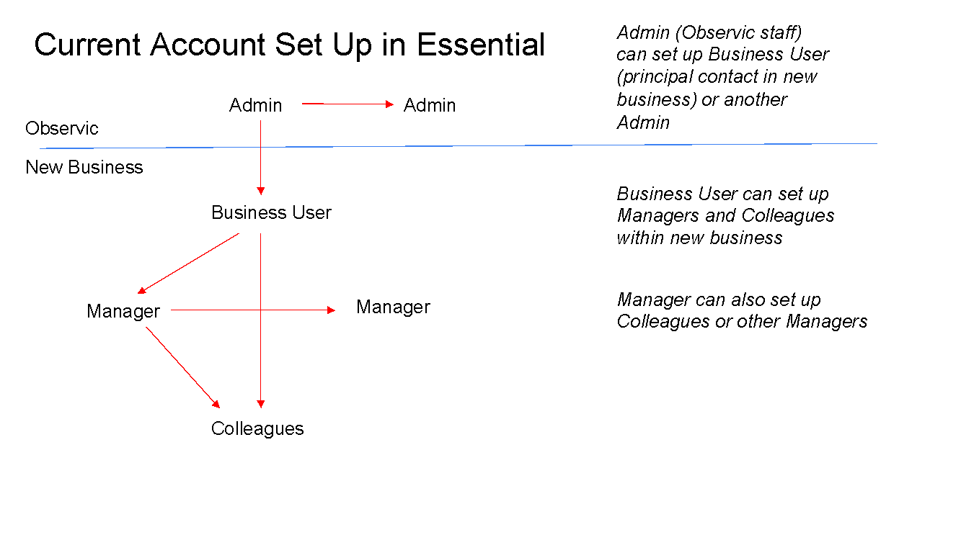

* 1. Problems have been encountered by users, including:
     1. Each new business is in a “silo” whereby the Observic Admin cannot add or transfer forms or content between instances
     2. There is only one single point of contact in the business and the Business User cannot give another user the same business user permissions
     3. There can be confusion between Business User and Manager in setting up and owning Users and User Groups and this has resulted in anomalies in who can access Reporting data
  2. The proposed new model changes both the names and permissions of various User Roles. The Observic Admin role becomes the Super Admin and allows manual set up of new instances and the addition of forms and content into a new instance or all instances. Alternatively, a new instance can be automatically set up by a new client purchasing a subscription for their business from the Observic website.
  3. The new model is shown below:

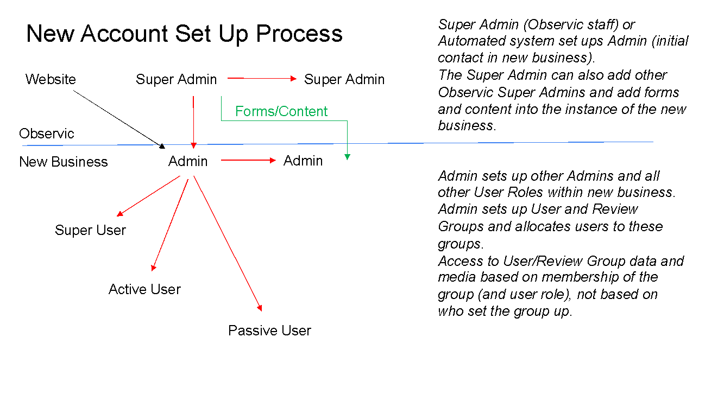

* 1. We envisage the same required information as Essential to set up a new instance and initial Admin account and then to set up all subsequent new users
  2. The existing Contracts function in Essential should be retained for the new Super Admin role and should be shown on the Home page as now

### [New User Roles](https://docs.google.com/presentation/u/0/d/1AbhLKyzzFIj9q5icOQDZrXSndp3wpdRA/edit)

* 1. **Admin** – has access to all parts of the platform and only user role to be able to manage all components – forms, users, groups, Good Practice, company details etc.
  2. **Super User** – Able to undertake all three review types and receive review requests. Has access to User Media libraries for those users who are also members of User groups the Super User is allocated to. Unlike the Active User, the Super user has access also to all Reporting within the instance. We assume this user role will be given to senior managers within an organisation

(Home for Admin and Super User - always directs to Reports)

* 1. **Active User** – the same permissions as the Super User *except* unable to access Reporting. This user role will be more likely for department managers/team leaders/mentors or regular staff that can review others.
  2. **Passive User** – can undertake self-reviews and request reviews from Admin/Super User/Active User. Cannot review other users or receive review requests, so should not appear in any *Add Reviewer* drop downs in Start Review. Start Review drop down menu should not include *Review someone else* option.

(Home for Active and Passive User - always directs to My Meetings)

* 1. The table below will appear as a pop up when an Admin is selecting the User Role for a user to inform them of permissions available to each role:

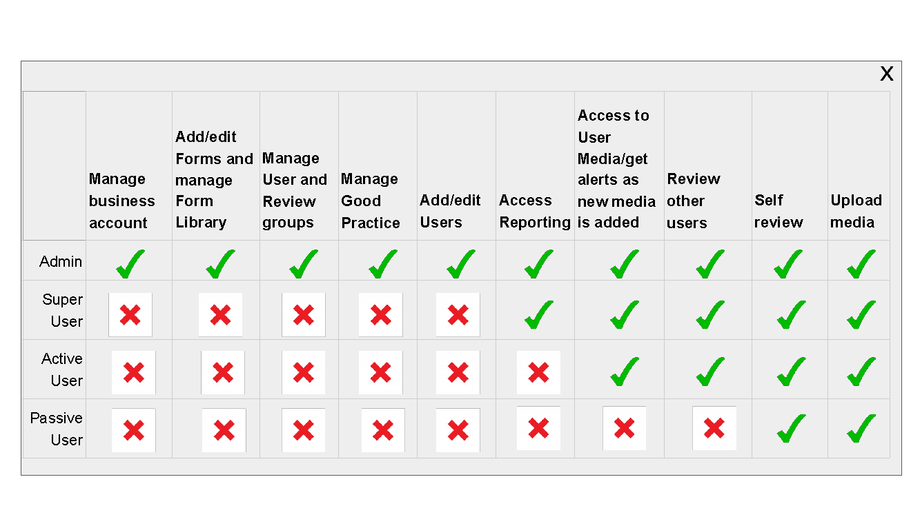

### Design Changes

* 1. A switch to a side menu bar layout and a more minimalist look and feel is outlined in the accompanying slide deck. **The developer is asked to provide some possible style sheets to review.** (Slide 13 [here](https://docs.google.com/presentation/d/1AbhLKyzzFIj9q5icOQDZrXSndp3wpdRA/edit?usp=sharing&ouid=107954330359441007251&rtpof=true&sd=true) shows an example of hope this could look. Slide 30 has an example of cleaner design)
  2. The new Menu bar items and associated drop downs per User Role are shown in the table below: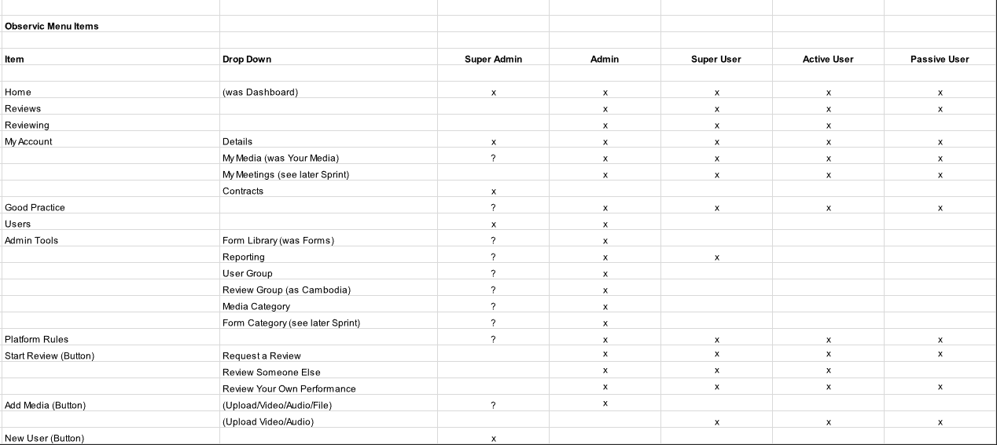
  3. The current News item in Essential should be hidden in the new menu bar
  4. Orientation of screen in My account>Details from horizontal to vertical.
  5. In the Item list are three buttons that could be placed in the sidebar or elsewhere. Of these, the New User button applies only to the Super Admin (as in Essential currently).
  6. It is suggested that the Start Review button contains a drop down listing the review type to be selected and thereby forgoing the need for a subsequent screen as in Essential.
  7. The Add Media button should follow the same format as in Essential, with the Admin having the ability to upload Video, Audio and File formats while all other users can upload Video and Audio files only.
  8. An Admin will have several extra functions in their Details screen:
  9. Add a Company logo (as Essential)
  10. Business Name (as Essential)
  11. In addition, they will have:
      1. Toggle button to switch off Email Notifications (as Cambodia)
      2. Toggle button to hide Good Practice from menu bar (New)
      3. Toggle button to omit self-review data from Reporting (New)
  12. Several question marks are included for Super Admin access to allow the developer to find the best solution to enable the Super Admin to add forms and content into all or specific instances.
  13. In Your Media we currently have the statement *Files are stored on the system for 2 months.* Please change this to 3 months and activate this rule - we think the coding is in place but has never been activated. This means media will be greyed out and removed after 3 months but this will not apply to any files stored in the Good Practice Library. Review data should always be retained in Reporting regardless of date.

### Low touch SaaS signup process ([See slides 31-36](https://docs.google.com/presentation/d/1AbhLKyzzFIj9q5icOQDZrXSndp3wpdRA/edit?usp=sharing&ouid=107954330359441007251&rtpof=true&sd=true))

* 1. Landing page (designs to be provided by Observic) with a signup process.
  2. This will allow visitors to the Observic website to create a new Observic account by logging in with Google or Microsoft account’s or manually with full name, email and password.
  3. (Provide same/similar signup options page as shown to invite new users, this will highlight the meeting recording/transcription tool)
  4. Email verification will be required.
  5. Onboarding will consist of the following:
  6. Screen 1: Organisation details
     1. Job title
     2. Organisation name
     3. Industry
  7. Screen 2: Create User Groups
     1. Shows explanation of user groups
     2. options to create them
     3. invite users to them
  8. Screen 3: Setup Forms
     1. Shows explanation of Forms
     2. options to setup forms
     3. assign them to user groups.
  9. All screens will allow for the option of ‘Do this later’ and ‘Save’.
  10. Once completed the user should be taken to the My meetings tab with a popup explaining why they are on this page and presented with options to setup or continue.
  11. (Mockups here)
  12. If they continue without setting this up they will be taken to their home screen. Aas they will be admin this will be the default home screen of Reports.

### Improvements

* 1. Is there now a newer tool that can be used for this image upload that can auto resize to the platforms that users don't need to have such a specific file type/size? (Discussed [here](https://observic.slack.com/archives/C0573GVF162/p1684723927630599))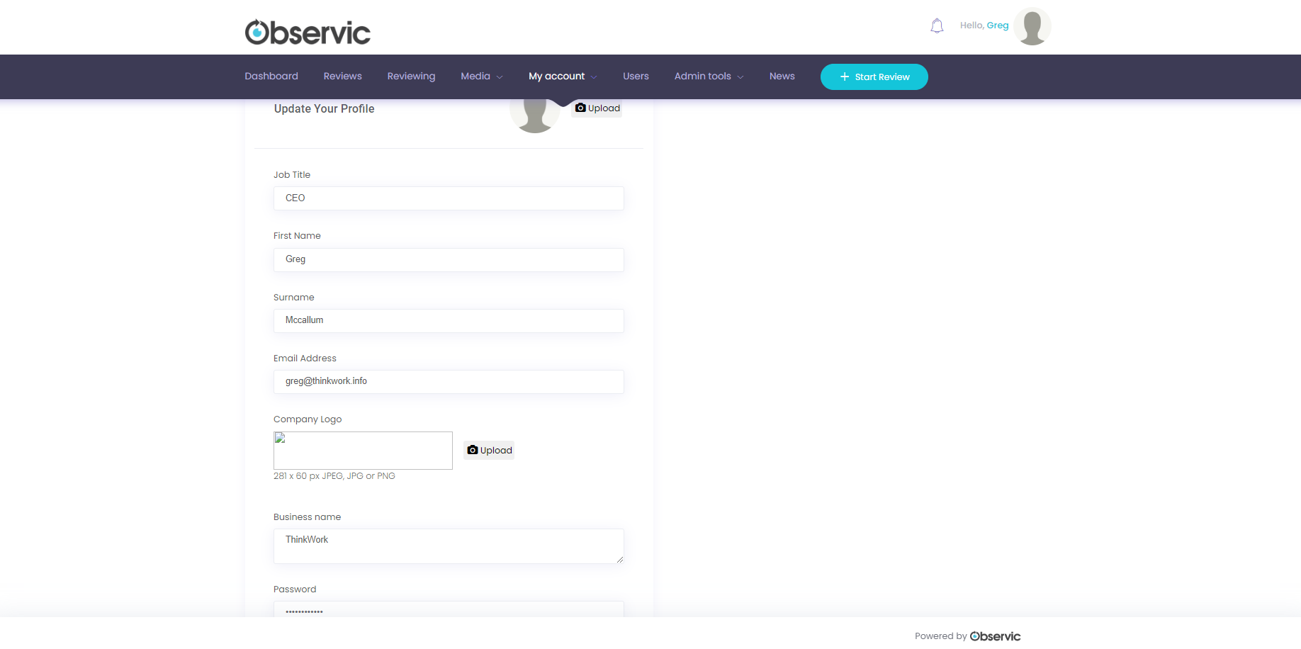

### Bugs to fix

* 1. Currently in Essential, a new thumbnail is added in Your Media each time a video or audio file is reviewed. Therefore, a video that has been reviewed frequently can swamp a user’s Media library with duplicates. This may also increase server and storage fees? We need to remove this duplication so that an uploaded file is shown as one thumbnail regardless of number of times reviewed. The developer is asked to suggest ways in which any previous reviews of a file can be shown in Your Media (which will be renamed My Media)
  2. Upload times into Your Media can still be slow and we need to relook and update our processes to enable more immediate upload
  3. By the same token, upload of a media file into the Review screen can be slow. As this file is already in the system, a user will expect the file to appear instantly and for playback rendering time to be fast.
  4. Boundary in profile overlay need to be fixed (email leeks out):
  5. 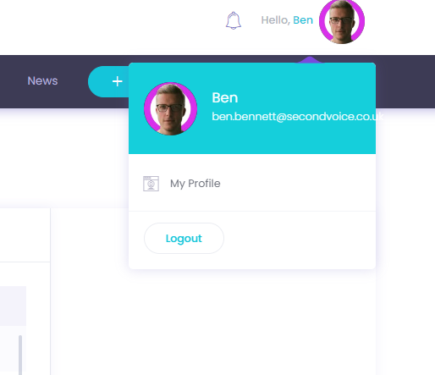

## Sprint 2 - Commencing 20 July 2023 – Scope of Work

Please refer to Slides 6 and 16-29 and to Spreadsheet Rows 10, 13, 15, 16. Note: Row 16 may have already been added in Sprint 1.

Blue text = new features/functions not listed in Slide Deck or Spreadsheet

### Admin Tools – Forms - Form Library

The Form Library is the first screen seen once Forms is clicked in Admin Tools.

Please raise the Form Library title to become a main heading and add the following instructions below:

“The Form Library allows you to manage, edit and build new forms. To edit an existing form, select Duplicate in the Action menu. Then edit, rename and save the duplicate as required. To make a form available in reviews, click Publish in the Action menu. To remove a form from use, click Unpublish. A published form will be available to all users within the User Groups selected for that form. Use the Add Form button to build a completely new form.”

**\*\*\*\*\**Replace Form Listing with: “Form Library”***

Change “Published” to Publish and “Unpublished” to Unpublish in Action drop down menu inside tile. Add Delete as fourth item in Action drop down menu. When Delete is clicked, an “Are you sure, this action will remove the form from your Form Library completely” pop up should appear with a Delete Form button.

***********(this change in remaining when user add form)

Allow Admin to add company logo to top right hand corner of tile for forms they have published (this will be possible when they have already uploaded a company logo to their account details). Forms added by John or Greg should have an Observic logo or icon.

### 

### 

### Form Builder

**\*\*\*\*\*\*\*\**Delete DIY Form and replace with: “Build a Form”***

***Add Form Category drop down menu between Form Title and Form Description – we will provide menu***

***Delete word “Section”***

See Admin Tools – Form Category below for Form Category drop down menu.

**\*\*\*\*\**Change instruction text to: “You can add from between 2 to 5 labels for each criteria. Include a descriptor for each label outlining the required competences and indicators”***

***\*\*\*\*Remove limit of three boxes – Reword instruction to: “Add comment box”***

***Dialogue icon automatically placed at end of form***

When editing a form, the Form Builder currently only deletes items once Save is clicked. Can the deleted items be seen to disappear immediately, before Save is clicked?

Please change two Save buttons at end of Form Builder to:

* Save Draft
* Save and Publish (this bypasses the need to then publish the form in the Action menu)

Please also check the icon used for Reply/Dialogue. Is there a more appropriate icon?

### Form Format

This will be the new format for all Forms within the Form Library and built with the Form Builder. Main change is the Descriptor rollover.

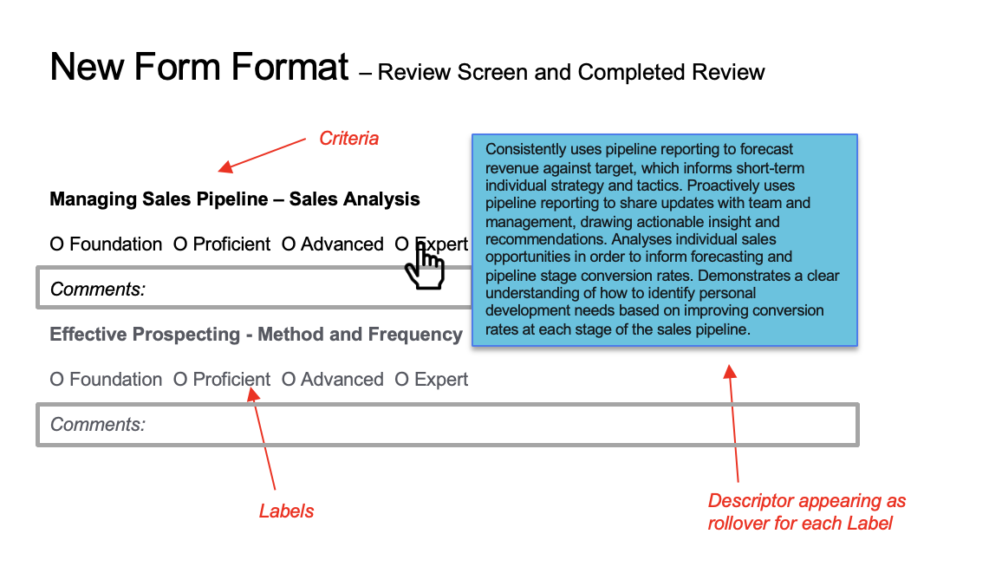

**\*\**Descriptor appearing as rollover for each Label***

**Consistently uses pipeline reporting to forecast revenue against target, which informs short-term individual strategy and tactics. Proactively uses pipeline reporting to share updates with team and management, drawing actionable insight and recommendations. Analyses individual sales opportunities in order to inform forecasting and pipeline stage conversion rates. Demonstrates a clear understanding of how to identify personal development needs based on improving conversion rates at each stage of the sales pipeline.**

**Labels are also changed**

### Your Media - User Media

This is a major change that would allow an Admin, Super User or Active User to view other users’ media *and* start a review through having access to other users’ Media libraries. (An Admin has access to all user’s media currently to select media for the Good Practice library, but not to start a review – therefore **we need to add** a Start Review button under each media file in addition to Add to Good Practice) – see screenshot below.

They would also be able to see if the file previously reviewed or not.

### Start Review

Add File function: we had originally decided to hide this in the review process as there are similar slow upload issues as with uploading video and audio files.(have to dicuss with mam)However, discussions with customers have shown that they are keen we retain the ability to upload and annotate documents as well as video and audio files. **Can we look at improving the upload and annotation process for documents please. This should include the ability to optimise to view either landscape or portrait documents.**

It is hard to select either reviewer or reviewee from drop down list in Start Review screen where there are large numbers of users (see screenshot below). **We need** (a) put user lists in alphabetical order and (b) have a Search facility where user types in name of person he/she is looking for. This same feature could also be added to Reporting for User drop down.

***********added to jira

### 

### Review Screen

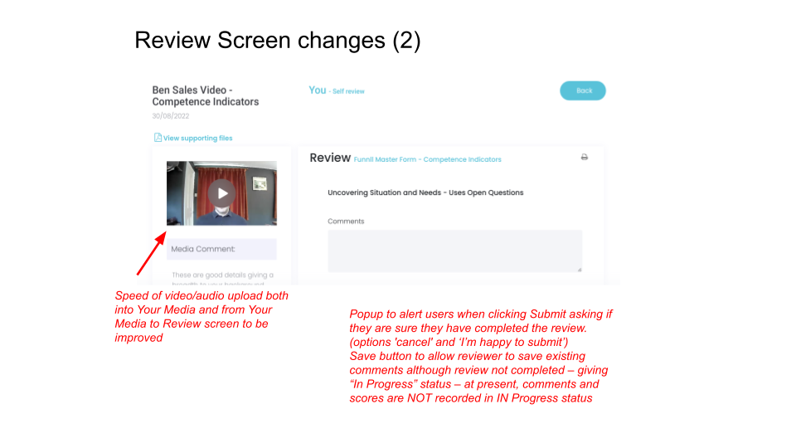

**\*\*\*\*\*\*\*\*\*\*\*this issue is log in jira**

### 

### 

### 

### Completed Review

### Admin Tools - Reporting

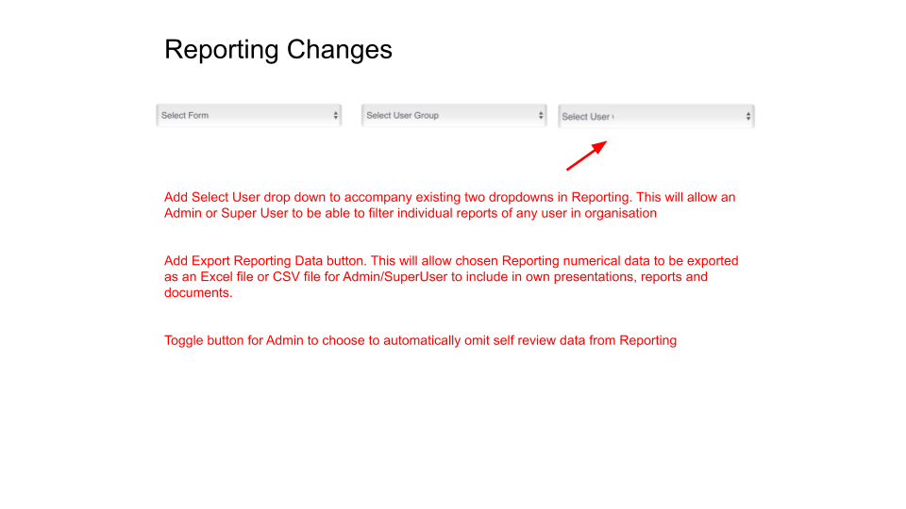

**\*\*\*\*\*\*\*\*\*\*\*\*also log in jira**

Add the same alphabetical list and Search facility to the Select User list as described in the Start Review section above.

Add two additional drop down filters to three shown above allowing Admin to select start and end dates for reviews in Reporting. These could be calendar pop-ups (as in booking a hotel website)

Pop-up box listing all reviews in a selected score should list both reviewers **and** reviewees. This currently only lists reviewees (see screenshot below).

### Admin Tools - Media Category

### Admin Tools - Form Category (new item in Admin Tools drop down)

*\*\*\*\*Text should read “Here you can add and manage Form Categories in Forms and your Form Library”*

Form Categories (not to be deleted):

* Sales
* Human Resources
* Marketing
* Operations
* Administration
* Finance
* Leadership/Management
* Technology
* Customer Support
* Customer Success
* Customer Onboarding
* Professional Development
* Recruitment

### Admin Tools - Review Frequency (new item in Admin Tools drop down)

Review Frequency screen for Admins to set the required frequency of reviews. The frequency selected will then trigger notifications to selected User Roles alerting them a review is due in 24 or 48 hours time. See Slide 30 and mock up below for suggested format:

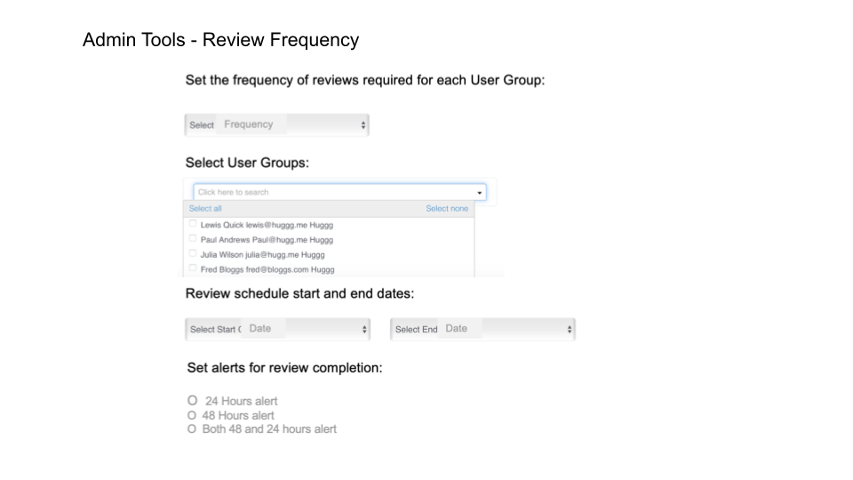

Suggested Text:

“Set the frequency of reviews required for each User Group:”

Drop-down menu items:

* Select Frequency
* Daily
* Every other day
* Twice a week
* Weekly
* Fortnightly
* Monthly
* Quarterly

“Select User Groups:” *(drop-down with checkboxes for each User Group in the system allowing one or more to be ticked. This will also allow the Admin to select different frequencies for different User Groups if they repeat the above process) Example in mock up above is for design purposes only as shows users rather than user groups.*

* All User Groups
* (Name of User Group)
* (Name of User Group)

“Review schedule start and end dates:”

*(Same calendar pop ups as in Reporting to enable Admin to select start and end dates)*

“Set alerts to complete the review:” *(radio buttons to select between)*

O 24 Hours alert

O 48 Hours alert

O Both 48 and 24 hours alert

Alerts text for header notifications & Email to user/s:

“You have outstanding reviews to complete within the next 24 hours.”

“You have outstanding reviews to complete within the next 48 hours.”

Alerts sent to all users within selected user groups except Passive Users.

**User Media Access**

This section is to clarify developer queries on Sprint 1 Section 2 New User Roles and add further detail.

Admins, Super Users and Active users will all be able to access User Media libraries, but in differing ways:

* Admins - can see User Media libraries for all users for review and adding to Good Practice - therefore there will be a Start Review button and a Add to Good Practice button under each file in User Media for Admins
* Super Users - can see User Media libraries for all users for review - therefore there will be a Start Review button under each file in User Media for Super Users
* Active Users - can see User Media libraries of members of User Groups the Active User is also a member of. They would select a User Group from the drop down menu in User Media which would list the User Groups they belong to and then select Users with the second drop down (as in current User Media). Active Users should also have a Start Review button under each file.

Two further points regarding User Media:

* For Admin, Super User and Active User clicking the Start Review button under a file in User Media should automatically default to the Review Someone Else page to commence the review
* The User drop down menu needs the same alphabetical list and Search facility which will be added in Start Review and Reporting (see above)